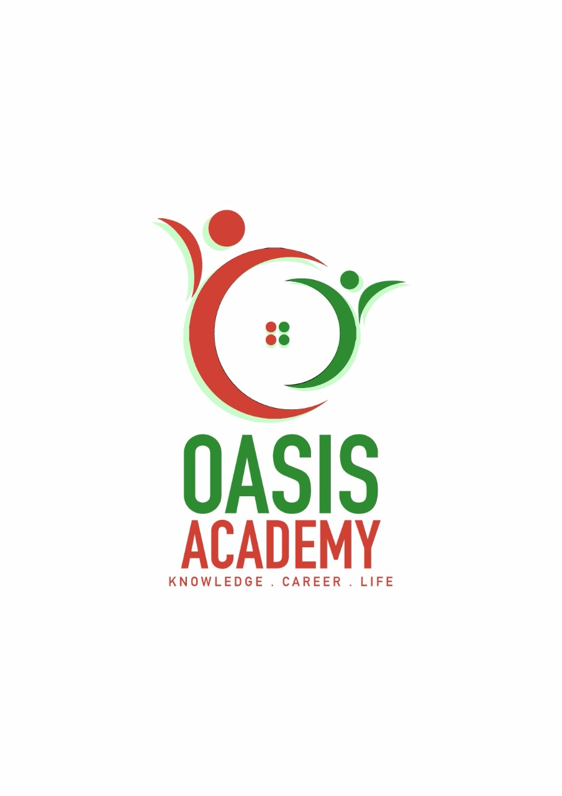

Name: YOGESIWARY THIAGARAJAN

Login ID: yogesiwary@oasis-portal.com

Course title: EXECUTIVE DIPLOMA in BUSINESS And HOSPITALITY

MANAGEMENT

Subject Code: BMH01

Submitted Date: 09 JUN 2017

**Table of Contents**

|  |  |  |
| --- | --- | --- |
| No | Details | Page |
| 1 | Executive Summary | 1 |
| 2 | Introduction | 1 |
| 3 | Assignment Question |  |
|  | Part 1 | 2 |
|  | Part 2 | 2 |
|  | Part 3 | 1 |
| 4 | Conclusion | 1 |
| 5 | References | 1 |

**Executive Summary**

Human resources management and hospitality industry is an essential part of HRM and FNB Human resources management in the project oriented organization is a relatively under explored topic.Human Resource Management (HRM) is the organizational function that deals with issues related to people such as compensation, hiring, performance management, organization development, safety, wellness, benefits, employee motivation, communication, administration, and training HRM Should be a core process in all organization because it affects the way they acquire and human resources and how employees experiences the employment relationship. Human resources are the people who work for the organization; human resource management is really employee management with an emphasis on those employees as assets of the business.  In this subject, employees are sometimes referred to as *human capital*. As with other business assets, the goal is to make effective use of employees, reducing risk Areas of HRM oversight include among many others employee recruitment and retention, exit interviews, motivation, assignment selection, labour law [compliance](http://searchdatamanagement.techtarget.com/definition/compliance), performance reviews, training, professional development, mediation, and [change management](http://searchcio-midmarket.techtarget.com/definition/change-management). Human resources management is of strategic importance to all organization and helping to create advantage. Human resources and hospitality should be linked both vertically and horizontally with the strategy choices

A : vertically so that human resources management practices support the organization`s strategy choices

B : horizontally ,so that human resources management practices support other operational practices .Human resource management is all about increasing employee performance to their highest level corresponding to their role in the organization. Since every organization is made of people, HRM is all about acquiring services of people, developing their skills, motivating them to the foremost level and making sure that they continue to maintain their commitment towards the organization. In short, HRM is concerned with the management of employees from recruitment to retirement.  Although there are many functions of human resource management, following is the list of five major functions.

The main the objective in this assignment what I studied about HRM first section I will explain about define the major activities and human resources relating to the organization its activities and operation ,organizational structure, Second section I will brief about on human resources planning trend in hospitality ,finally I will brief about organizational behaviour in hospitality

**Introduction**

Human resources management is relatively new approach to managing people in organization. Human resources management is a process, which consists of main activities, namely, development, motivation as well as maintenance of human resources. Human resources management is the development and implementation of systems in an organization design to attract develop and retain a high –performing workforce. Human resources management is steadily becoming recognized as essential for organizational success. Human resources departments are called upon to administer activities related to workers who may be critical to the continued success of the organization. The human resources management function has development, since the early days of the industrial, revolution until today. (Online)

The hospitality industry in general, including businesses such as restaurants and hotels. The organization serves the community and often uses a lot of staff. The hospitality industry is competitive. Which identified the hospitality industry`s now and in the future, reiterated what a demanding few years the hospitality industry have experienced

Smart operators are responding to the challenges of economic through initiatives that provide a point of difference from the competitors, social media, sustainability and technology, facing hospitality business is food court, building and maintaining sales volume, operations coats. The human resources department role is support the organization by freeing up management to concentrate on of doing business. The demand in hospitality industry increasing, this is driven largely by guest expectations, which are higher than ever before guest have the latest technology, hospitality and business management resources was one of the hardest –hit segments of the global and fast growing industry. Business management are driving growth in the hospitality markets in all regions of world.

Human resource management is the arrangement of employees and their work in an organization, it is the science related to human and its allocation in the workplace. Simply we can say it the management of human or people. HRM is a managerial system that tries to meet organizational needs to the potentials and capabilities of its workers. The responsibility of HRM is to handle people at work. This department is also responsible for bringing people in organization assisting them perform their work, compensating them for work and dealing with problems. HRM plays important role in forming organizations and serving them survive. Our world is an organizational.

**THE MAJOR ACTIVITIES OF HUMAN RESOURCES MANAGEMENT**

The process of hiring and developing employees so that they become more valuable to the organization .Human resources management includes conducting job planning personnel needs ,recruiting the right people for job and training ,managing and salaries, providing benefits and incentives, evaluating perfomances,resolving disputes and communicating with all employees at all levels

### 

**A .Recruitment and Selection**

Recruitment and selection is all about predicting future performance. Employers distinguish between a jobs applicants who will be able to carry out his duties adequately. Selecting the suitable people from a large pool of applicants is an incredible responsibility. This engrosses an acute sense of perceptiveness while sifting through amasses of applications that come a company's way. After the short listing process is over, the HR department progresses to the task of scheduling and conducting interviews. At this point, the HR managers have to assess the candidate on different levels, right from their educational qualifications and capacity, to their character qualities. They may also have to relate various techniques of evaluation to zero in on the right people for the job

Recruitment and selection procedures based on up to date research will improve the like probability an employer hiring suitable staff. Accomplishing background checks on the chosen candidates may also come under the auspices of the HR department. The chapter will describe the steps an employer should follow in the recruitment and selection process.

Human resources planning is a continuous process of the requirements for manpower with the financial and operational plan of the organization in a particular time. Human resources planning allows the human resources department to anticipate the manpower need to organization and help to reduce crisis situation such as severe shortage or oversupply of workers.in coffee shops and restaurants, for an example, self-services would require a complete revamping of the way business is conducted. Many services that are needed by companies but not necessarily central to their core business.

Selection is the process of choosing the most suitable candidate from a group of applicants for an available vacancy. Choose the most of suitable candidate, information must be collected and each applicant carefully assessed and compared. This is most crucial step in the recruitment and selection process. If unsuitable worker is recruited, not only will be necessary to go through the harrowing process of dismissing the newly recruited worker.

**2. Orientation**

Many organizations do not provide a thorough orientation to the new employees. This is the fundamental step to help a new employee to adjust himself with the employer and with his new job. Employee orientation program should include the objectives and goals of the organization and how the employee can help to achieve the long-term and short-term goals of the organization.

Giving intensive orientation to the employee is one of the major functions of human resource management. The program should help the employee to know his assigned duties and his exact job description, job role, and the relationship of position to other positions in the organization. It gives clarification to the employee to take an active role in the organization.

**3. Maintaining good working conditions**

It is the responsibility of the human resource management to provide good working conditions to the employee so that they may like the workplace and the work environment. It is the fundamental duty of the HR department to motivate the employees. The study has been found that employees don’t contribute to the goals of the organization as much as they can. This is because of the lack of motivation.

Human resource management should come up with a system to provide financial and non-financial benefits to the employee from the various departments. Employee welfare is another concept which should be managed by

HR team. Employee welfare promotes job satisfaction.

**4. Managing Employee relations**

Employees are the pillars of any organization. Employee relationship is a very broad concept and it is one of the crucial functions of human resource management. It also helps to foster good employee relations. They have the ability to influence behaviours and work outputs.

Management should organize activities which will help to know an employee at the personal and professional level. Well-planned employee relations will promote a healthy and balanced relation between the employee and the employer. It is the key for the organization to be successful.

**5. Training and development**

Training and development are the indispensable functions of human resource management. It is the attempt to improve the current or future performance of an employee by increasing the ability of an employee through educating and increasing one’s skills or knowledge in the particular subject.

**Question 2: The strategic HR planning process**

The strategic HR planning process has four steps:

**Assessing current HR capacity**

The first step in the strategic HR planning process is to assess the current HR capacity of the organization. The knowledge, skills and abilities of your current staff need to be identified. This can be done by developing a skills inventory for each employee.

**Forecasting HR requirements**

The next step is to forecast HR needs for the future based on the strategic goals of the organization. Realistic forecasting of human resources involves estimating both demand and supply. Questions to be answered include:

* How many staff will be required to achieve the strategic goals of the organization?
* What jobs will need to be filled?
* What skill sets will people need?

When forecasting demands for HR, you must also assess the challenges that you will have in meeting your staffing need based on the external environment. To determine external impacts, you may want to consider some of the following factors:

* How does the current economy affect our work and our ability to attract new employees?
* How do current technological or cultural shifts impact the way we work and the skilled labor we require?
* What changes are occurring in the Canadian labor market?
* How is our community changing or expected to change in the near future?

**Demand forecasting**

Demand forecasting is analyzing data to predict future sales for your organization. As time travel is still a mystery to us and it’s impossible to know what the future holds, it’s important to predict demand based on past trends and what you expect to happen. What new jobs will we need?

* What new skills will be required?
* Do our present employees have the required skills?
* Are employees currently in positions that use their strengths?
* Do we have enough managers/supervisors?
* Are current HR management practices adequate for future needs?

**Action Planning**

There are several HR strategies for meeting your organization's needs in the future:

* Restructuring strategies
* Training and development strategies
* Recruitment strategies
* Outsourcing strategies
* Collaboration strategies

**Question 3: Human resource management policies**

**Professional Image and Grooming Standards**

Personal Hygiene is required by all team members, such as daily bathing, shaving, use of deodorant, and brushing teeth, etc. Colognes/perfumes should be used conservatively and tastefully applied. Hats should not be worn unless issued as part of the uniform. Name Tags are required. Shoes should conform to applicable department and safety standards. Shoes should be closed toe and heel, well-polished and business-like appearance. Tattoos must be discrete. Hair should be groomed in style and colour and should not interfere with eye-to-eye contact. Male team members must either be clean-shaven or have a conservative neatly trimmed beard, goatee, or moustache.

**Training and development**

Human resource team is responsible in providing the required training to employees to avoid job breakdowns. It is HR department responsibility to make sure knowledge gained during training period are executed by employees properly. Sample training that can be provided to ensure good workflow are as follows: provide good communication skills for performing required job, educate employee on food and beverage service manual to make sure they are aware of the setting of services, table setting and place setting. Methods of table service such as plate service, cart service and platter service. Restaurant service such as welcoming the guest, menu knowledge, taking order, presenting the bills, and accidents in the dining hall. Banquet services such as service protocol, welcoming the host and types of banquet services.

Management team is also required sustain employee satisfaction at all time in order to sustain them. This could be done by providing necessary compensation and rewards to well performing employee. Besides that a good and save working environment will make sure employees stay healthy and mentally focused to perform task. Proper work distribution and working hours are vital. Making sure all employees get good resting hours is necessary to avoid employee from falling sick. Other than that management team is required to make sure proper communication between all employee and managers. Proper communication is vital to avoid conflict among staff and miss understanding.

**Motivation**

The management believes that maintaining and fresh recoganizitin schemes is key to increase motivation of employees in hospitality industry according to this motivation there are some factor that encourage employee at working place such as ,communication training and development plans ,the management will build personal development plan for each employee, it support induvual to achieving they potentials by encourage self-assessment and giving them on session of training ,this enable workers to take they own responsibility .Whether the economy is growing or shrinking, finding ways to motivate employees is always a management concern. Management could motivate their employee by giving award like the best employee of the month, one way to motivate co-workers in a team is to share all the praise that one gets, Keep the Blame, Never shift blame to another, however much they deserve it. Just apologize and say that you will not repeat the error. Ask for Feedback Always be open to feedback from your team. Ask your team members for their views and opinions on work related issues. Make sure you incorporate at least some of these in your work.

**Question 4: Organizational behavior in hospitality management**

This chapter is explain about evolution of leadership ,culture and structure for the management of the hospitality team activities to the requirement the corporate arrangement of bistro is compared to other business organization for the understanding of district setting on performance and behaviors of human resources. The management organized separate division with responsibility for individual services group. The general manager’s control all employee are mostly concentrate on providing services.

The following main culture types : -

Control : These are controlled plus structure with stability and doing right things like food and beverage industry follow culture as the managers always stress and think services standization

Complete ( market ) : This is oriented culture with a concentration on achievements and competitions .All division of business were not be on first or second position in the market

Corporate : This culture focus on monitoring and performing this together providing environment to employee and give changes to learn and grow in future

Create : Dynamic with a concentration on innovation and risk it has become the market leader through its ability to fast capture in market and introduce new services .

**Conclusion**

As the business environment is getting more competitive, organizations in different industries need to gain some access to those resources in which they have gain the competitive advantage to increase the profitability. The above report is being constructed in this similar regard, in which it was required to select an author which has written on the topic of culture and then the concepts earned through that book was being incorporated in this research report which is based on the importance of Human Resource Management in the international industry.

Therefore the report is constructed in a logical manner followed from the evolution of the Hospitality industry, in this part the different factors have been discussed which has resulted in the boost of the entire industry; the main factor which has influenced is the globalization. Then the importance of culture is being discussed and how the realization of the culture is important in the international business environment and also different factors of the culture are being discussed.

In the end part of the report, the importance of Human resource management is being discussed and how human resource manager can play its role in the development of the organizational performance. There are few issues also discussed in which the basic emphasis was on to have an appropriate inductions system by which the organization will be able to hire best employees.

**References**

* 1. <http://archive.mu.ac.in/myweb_test/M.Com.%20Study%20Material/Human%20Res.%20Management%20-%20M.%20Com%20-%20I.pdf>
  2. <http://www.whatishumanresource.com/human-resource-management>
  3. <http://hrcouncil.ca/hr-toolkit/planning-strategic.cfm?subject=http://hrcouncil.ca/hr-toolkit/planning-strategic.cfm>
  4. <https://www.inc.com/encyclopedia/human-resource-policies.html>
  5. <https://goricastanisic.wordpress.com/2013/11/20/organisational-behaviour-in-hospitality-industry/>